Name: Satyaki Das  Department of Computer Science & Engineering  Email: satyaki.das@ulab.edu.bd  Contact: +8801712957180  Office Room: PC-315  Quote (if any)  “People don’t care how much you know until they know how much you care.” | 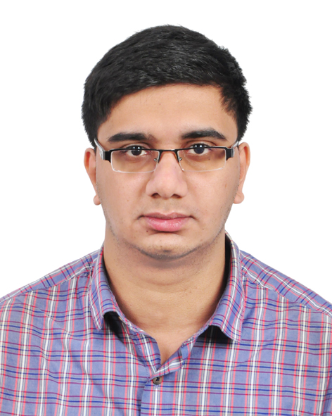

Semester Routine/ Semester Schedule
Day | Class Hours |  |  | Counseling Hours  Room:
Day | Courses | Time | Room | Day | Time
Sunday | CSE 306 – 01 | 10:00 - 11:20 | PB 106 | Sunday | 1:00 - 2:30
Sunday | CSE 304 – 02 | 11:30 - 12:50 | PB 103 | Sunday | 1:00 - 2:30
Sunday | CSE 404 – 01 | 2:40 - 4:00 | PA 201 | Sunday | 1:00 - 2:30
Monday | CSE 306 – 02 | 10:00 - 11:20 | PB 106 | Monday | 11:30 - 12:50  &  2:30 - 4:00
Monday | CSE 480 – 01 | 1:10 - 2:30 | PB 105 | Monday | 11:30 - 12:50  &  2:30 - 4:00
Monday | CSE 201 – 02 | 4:10 - 5:30 | PD 202 | Monday | 11:30 - 12:50  &  2:30 - 4:00
Tuesday | CSE 306 – 01 | 10:00 - 11:20 | PB 106 | Tuesday | 1:00 - 2:30
Tuesday | CSE 304 – 02 | 11:30 - 12:50 | PB 103 | Tuesday | 1:00 - 2:30
Tuesday | CSE 404 – 01 | 2:40 - 4:00 | PA 201 | Tuesday | 1:00 - 2:30
Wednesday | CSE 306 – 02 | 10:00 - 11:20 | PB 106 | Wednesday | 11:30 - 12:50  &  2:30 - 4:00
Wednesday | CSE 480 – 01 | 1:10 - 2:30 | PB 105 | Wednesday | 11:30 - 12:50  &  2:30 - 4:00
Wednesday | CSE 201 – 02 | 4:10 - 5:30 | PD 202 | Wednesday | 11:30 - 12:50  &  2:30 - 4:00
Thursday |  |  |  | Thursday | Available by appointment
To make appointment at some other time (except counseling hour), please contact via email

